V1 content by John Michael Raimondi and Ben Ward

V2 content by Phillip Owens and Nicholas Morgan

User’s Guide

For Veterans Museum Viewer and Administrator Applications V2.0

Contents

Viewer Application 2

Searching For A Veteran Record 2

The Cemetery Information Page 3

The Google Maps button 3

The FindaGrave button 3

Submitting Corrections / Updates To The Record 4

Administrator Application 5

Veterans 5

Add Single Veteran 5

Add Veterans By Cemetery 5

Search To Edit Existing Veteran 5

Adding / Editing Data 5

Cemeteries 10

Branches 10

Ranks 10

Conflicts 10

Awards 11

User Comments 11

Queries 11

Installation Instructions 12

Installing MariaDB 12

Installing The Viewer And Administrator Applications 14

Configuring MariaDB, Viewer, And Administrator Applications 15

Editing The Viewer And Administrator Application Config Files 15

Editing The Database Users Config File 16

Importing Data And Configuration Files Into The Database 17

Setting up daily Backups 17

References 22

# Viewer Application

The viewer application is designed to be used by the public. It does not have the ability to edit the existing data in the database. A *Submit Corrections / Updates* button is available which allows a submission of text up to 3000 characters. The corrections / updates are submitted for later approval.

## Searching For A Veteran Record

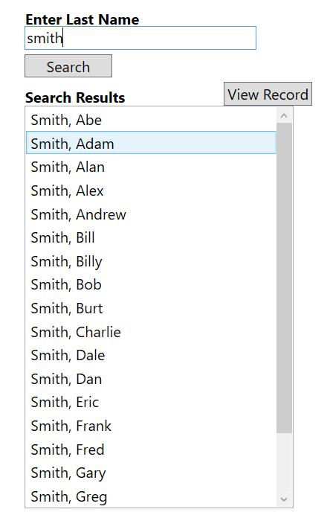Upon launching the application, the user will encounter a window that will prompt them to enter a last name of a veteran to search for. Pressing enter or clicking the *Search* button will either load the record, load a list of multiple veterans with the same last name, or load a popup window with the message “No record found for the last name [*last name*]. The name must be spelled as it is in the database, or a match will not occur. In the event of multiple veterans with the same last name, a list will be populated as shown below.

Figure 1

Select the veteran you wish to view and click the *View Record* button to view the associated record. Once the record is loaded, you can view the record, click the *Submit Corrections / Updates* button if you feel like information is missing or incorrect. Clicking any photo in either the veteran record or cemetery information will open a window with an enlarged version of the photo. If the last name returned multiple veterans, *Previous* and *Next* buttons will be available to view the other records with the same last name. Once you have completed viewing the selected veteran record, click the *Search Again* button to return to the main menu to search for a different veteran.

## The Cemetery Information Page

Clicking the Cemetery Information button will bring up the Cemetery Information page. This page contains information about the cemetery where the veteran is buried. The page will contain the cemetery’s address, latitude and longitude, aerial picture, and picture of directions to the cemetery. The Cemetery Information page also contains the “Google Maps” and “FindaGrave” buttons.

### 

### The Google Maps button

Clicking the google maps button will launch Internet Explorer with the cemetery name and address preloaded into the search bar. Clicking the magnifying glass icon next to the search bar will initiate the search. The Google Maps website can be used as normal from here.

### The FindaGrave button

Clicking the “FindaGrave” button will launch Internet Explorer with the custom URL applied in the Admin App. See the Admin section for details on adding a FindaGrave link.

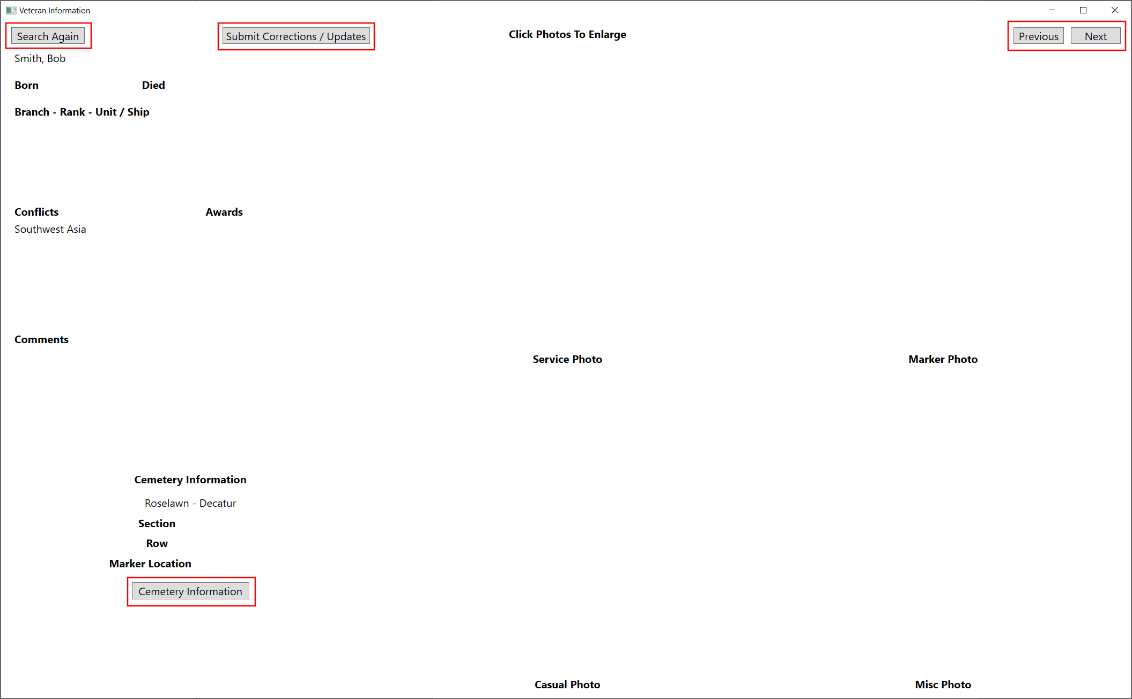

## Submitting Corrections / Updates To The Record

When viewing a veteran record, clicking the *Submit Corrections / Updates* button will open a window with text box allowing the user to add comments. The text box allows up to 3000 characters to be submitted. Click the *Save And Close* button to save the comment and close the window, or click the *Close Without Saving* button to close the window and discard any typed comment.

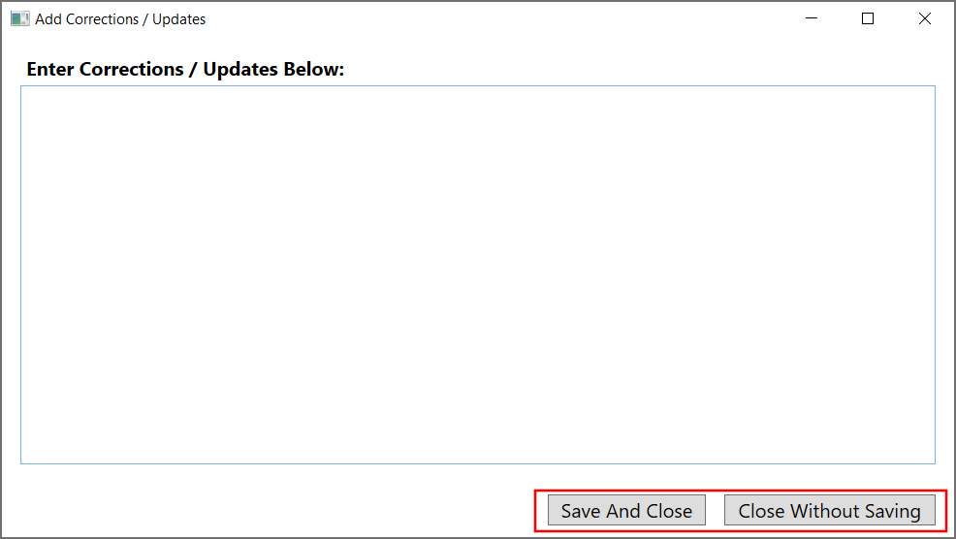

# Administrator Application

The administrator application is designed to be used by trusted employees and volunteers of the veterans museum, not the public. It has the ability to edit and delete any data in the database.

## Veterans

The Veterans view can add, edit, or delete veterans contained in the database.

### Add Single Veteran

Clicking the *Add Veteran* button in the **Add Single Veteran** section will open a blank veteran record. This will allow creation of a veteran record with all fields available.

### Add Veterans By Cemetery

In the **Add Veterans By Cemetery** section you can select an existing cemetery in the database and click *Quick Add* to open a short form blank record. This will allow creation of veteran records preset to the given cemetery information. This form does not allow adding awards, comments, or photos. The veterans added by this method can be edited later to add the missing awards, comments, or photos, if desired.

### Search To Edit Existing Veteran

The **Search To Edit Existing Veteran** section operates like the viewer application. Enter the last name of a veteran to edit, then pressing enter or clicking the *Search* button will either load the record, load a list of multiple veterans with the same last name, or load a popup window with the message “No record found for the last name [*last name*]”. The last name must be spelled as it is in the database, or a match will not occur. In the event of multiple veterans with the same last name, a list will be populated as shown in Figure 1 on page 2. Select the veteran you wish to view and click the *View Record* button to view the associated record. If the last name returned multiple veterans, *Previous* and *Next* buttons will be available to view the other records with the same last name.

### Adding / Editing Data

Once a blank or existing record has been opened, the operations are similar. There are several text boxes that can be filled with the veteran data. The **Cemetery** field is a dropdown with a list of all of the cemeteries currently contained in the database. The following sections describe fields that are more complicated than the simple text boxes.

#### Born and Died Date Fields

The **Born** and **Died** fields are date fields. These can accept many formats of dates but once they have lost focus (the user has selected a different field) the boxes will auto-convert to the MM/DD/YYYY format.

#### Service Details

The **Branch – Rank – Unit / Ship** section is controlled by the three buttons to its right, see Figure 2. Click *Add Details* to open a window with a blank record, the record details the branch, rank, and unit or ship. Select an item in the list, and click *Edit Details* to open a window prefilled with the existing information. With either option, a window will open containing two dropdowns and one text field, see Figure 3.Select the branch and then select the rank. The unit / ship field is a text box to fill with free form text. A branch must be selected prior to selecting a rank, the application will only show the ranks that apply to a given branch. Press *Ok* to save it to the veteran record. Pressing the *Cancel* button will discard the information. Selecting an existing record in the box and clicking the *Delete Details* button will remove that service detail record from the current veteran.

Figure 2

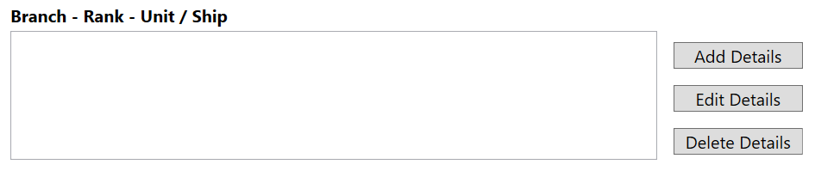

Figure 3

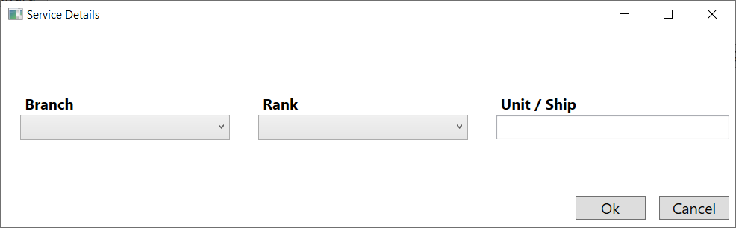

#### Conflict Details

The **Conflicts** section is controlled by the three buttons to its right, see Figure 4. Click *Add Conflict* to open a window with a blank record. Select an existing record in the box and click *Edit Conflict* to open a window prefilled with the existing information. With either option, a window will open containing a dropdown, see Figure 5. Select the conflict and press *Ok* to save it to the veteran record. Pressing the *Cancel* button will discard the information. Selecting an item in the list and clicking the *Delete Conflict* button will remove that conflict record from the current veteran.

Figure 4

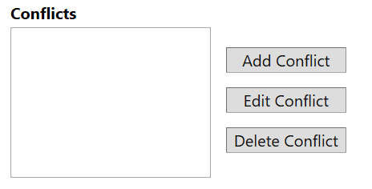

Figure 5

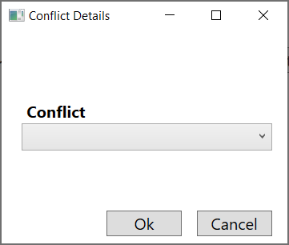

#### Award Details

The **Awards** section is controlled by the three buttons to its right, see Figure 6. Click *Add Award* to open a window with a blank record. Select an existing record in the box and click *Edit Award* to open a window prefilled with the existing information. With either option, a window will open containing two dropdowns, see Figure 7. Select the branch and then select the award. A branch must be selected prior to selecting an award, the application will only show the awards that apply to a given branch. Press *Ok* to save it to the veteran record. Pressing the *Cancel* button will discard the information. Selecting an item in the list and clicking the *Delete Award* button will remove that award record from the current veteran.

Figure 6

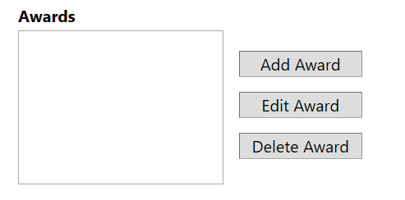

Figure 7

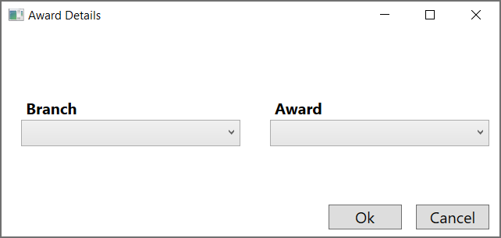

#### Photos

The **Service Photo**, **Casual Photo**, and **(2)** **Misc Photo** sections all contain *Set Photo* and *Delete Photo* buttons, see Figure 8. Clicking the *Set Photo* button will allow the user to select a new photo to replace the current one (in the case of an empty photo, it simply adds the photo). Clicking the *Delete Photo* button removes the current photo and does not replace it.

#### New Record, Save Record, and Delete Record

The *New Record*, *Save Record*, and *Delete Record* buttons are located in the top left of the window, see Figure 8 The *Save Record* button writes the current record to the database. This also writes the **Branch – Rank – Unit / Ship**, **Conflicts**, and **Awards** sections to the database so it must be pressed if any of those are changed. If the user attempts to change to a different view or record, or attempts to close the application with unsaved data, a window will pop up to confirm that they wish to discard the unsaved information. The *Delete Record* button will remove this veteran record from the database. Successful save attempts are indicated by a pop-up window. The *New Record* button will clear all fields for the next veteran’s data.

Figure 8

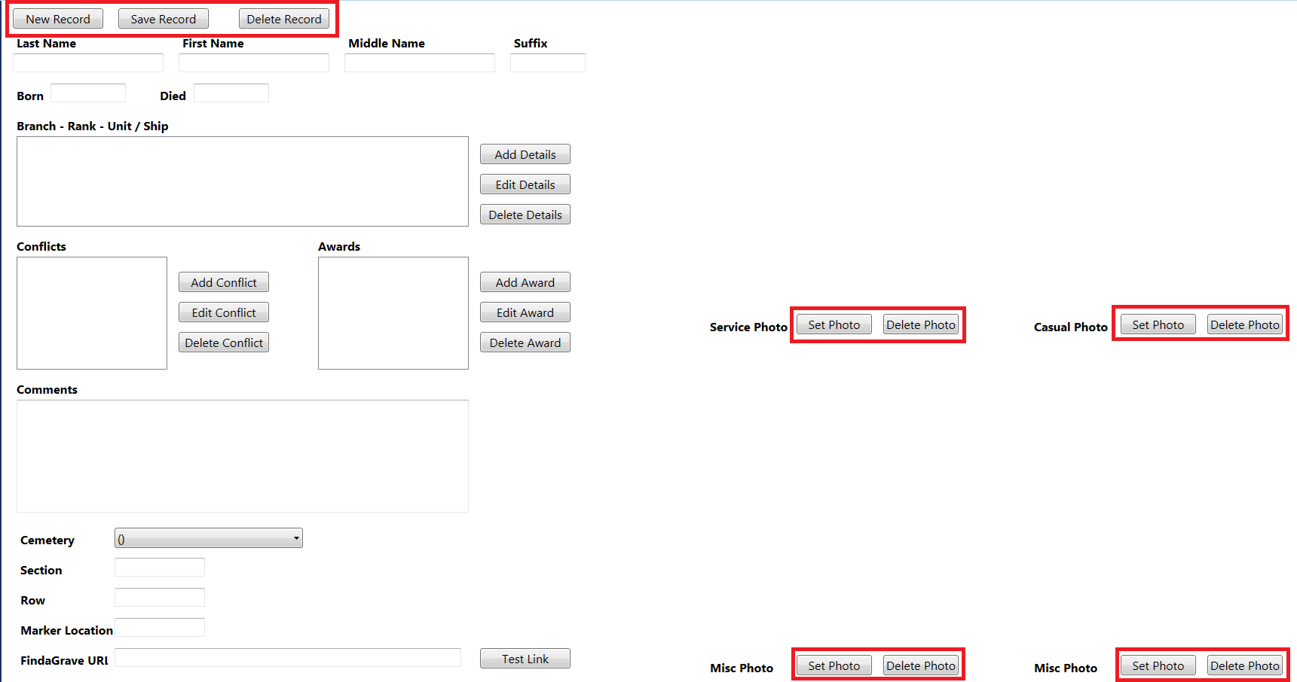

#### The FindaGrave URL box and Test Link Button

If the veteran has a page on the website [www.FindaGrave.com](http://www.FindaGrave.com), the URL for the veterans page can be copied and pasted into the FindaGrave URL box. Once the veterans information is saved the The FindaGrave button in the Cemetery Information page in the viewer app will launch Internet Explorer and take the user directly to the page linked in this box.

## Cemeteries

The Cemeteries view lists the names and cities of all cemeteries contained in the database and can add, edit, or delete these cemeteries. To add a new cemetery to the database, click the *Add Cemetery* button to open an empty record. Select an item in the list and click the *Edit Cemetery* button to open an existing record to edit the name, address, city, GPS coordinates, directions photo or aerial photo associated with that cemetery. Enter or edit the appropriate information in the text boxes attached to the labels in bold. For the directions and aerial photos, clicking the *Set Photo* button will allow the user to select a new photo to replace the current one (in the case of an empty photo, it simply adds the photo). Clicking the *Delete Photo* button removes the current photo and does not replace it. Click the *Save* button to write the information to the database, or click the *Cancel* button to discard changes. Select an item in the list and click the *Delete Cemetery* button to remove the cemetery from the database.

## Branches

The Branches view lists the names of all branches contained in the database and can add, edit, or delete these branches. To add a new branch to the database, click the *Add Branch* button to open an empty record. Select an item in the list and click the *Edit Branch* button to open an existing record to edit the name or picture associated with that branch. Enter or edit the name of the branch under the label **Branch Name**. Clicking the *Set Photo* button will allow the user to select a new photo to replace the current one (in the case of an empty photo, it simply adds the photo). Clicking the *Delete Photo* button removes the current photo and does not replace it. Click the *Save* button to write the information to the database, or click the *Cancel* button to discard changes. Select an item in the list and click the *Delete Branch* button to remove the branch from the database.

## Ranks

The Ranks view lists the names of all ranks contained in the database for a given branch and can add, edit, or delete these ranks. Clicking the dropdown under the **Branch** label will list all branches in the database. Select a branch to see the ranks for the given branch. To add a new rank for the selected branch to the database, click the *Add Rank* button to open an empty record. Select an item in the list and click the *Edit Rank* button to open an existing record to edit the name and abbreviation of that rank. Enter or edit the name of the rank under the label **Rank Name**. Optionally, enter or edit the abbreviation for the rank under the label **Rank Abbreviation**. Click the *Save* button to write the information to the database, or click the *Cancel* button to discard changes. Select an item in the list and click the *Delete Rank* button to remove the rank from the database.

## Conflicts

The Conflicts view lists the names of all conflicts contained in the database and can add, edit, or delete these conflicts. To add a new conflict to the database, click the *Add Conflict* button to open an empty record. Select an item in the list and click the *Edit Conflict* button to open an existing record to edit the name of that conflict. Enter or edit the name of the conflict under the label **Conflict Name**. Click the *Save* button to write the information to the database, or click the *Cancel* button to discard changes. Select an item in the list and click the *Delete Conflict* button to remove the conflict from the database.

## Awards

The Awards view lists the names of all awards contained in the database for a given branch and can add, edit, or delete these awards. Clicking the dropdown under the **Branch** label will list all branches in the database. Select a branch to see the awards for the given branch. Click the *Add Award* button to open an empty record to add a new award for the selected branch to the database. Select an item in the list and click the *Edit Award* button to open an existing record to edit the name of that award. Enter or edit the name of the award under the label **Award Name**. Click the *Save* button to write the information to the database, or click the *Cancel* button to discard changes. Select an item in the list and click the *Delete Award* button to remove the award from the database.

## User Comments

The User Comments view lists the names of veterans who have comments submitted by users of the viewer application. Select a name and click the *View Comment* button to open a split view of the comment and the veteran record tied to that comment. If multiple comments are present, *Previous* and *Next* buttons will be visible to view the other comments in the database, regardless if the comments reference the same or different veterans.

On the left, with a light blue background, will be the comment submitted in the viewer application. On the right, with a white background, will be the veteran record that is tied to the comment. The comment is not editable, and clicking the *Delete Correction* button will remove the comment from the database. The veteran record operates as detailed in the Adding / Editing Data heading on page 5. Be sure to save the veteran record if any data was added or updated, and to delete the comment after updating the veteran record. The deleting of the comment and saving the record are not tied together to allow deletion of superfluous comments without affecting the veteran record and to allow saving small changes detailed in the comment while deferring larger changes that may require the comment to continue existing for research before modifying the associated veteran record.

## Queries

The Queries view allows reports to be ran against the database. The queries are designed to be shown as a normal English command or question. The first line under each heading in bold has two dropdown lists. The first dropdown lets the user select if they would like a count (How many) or a list (List the) of the veterans. The second dropdown lets the user select the cemetery, branch, or conflict for the query. The second line under each heading lists all cemeteries, branches, or conflicts with a count of veterans. This is running a “How many veterans in all cemeteries / branches / conflicts?” report.

# Installation Instructions

Installation requires installing MariaDB, installing the viewer and administrator applications, and configuring MariaDB and the applications to work together.

## Installing MariaDB

MariaDB is a free database program that is downloadable from the internet. The viewer and administrator applications use MariaDB to store data. An installation package is present on the installation USB drive. Once you have downloaded the software, or located it on the installation USB drive, double-click it to begin the installation process.

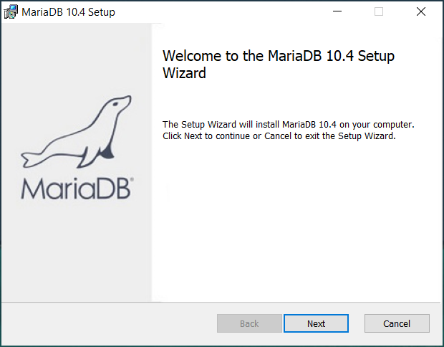

Click Next.

Accept the license agreement and click next.

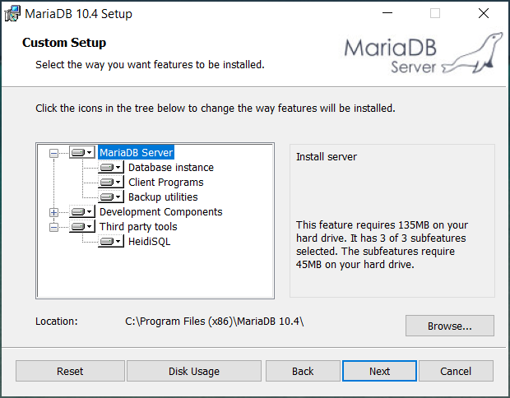

Click Next.

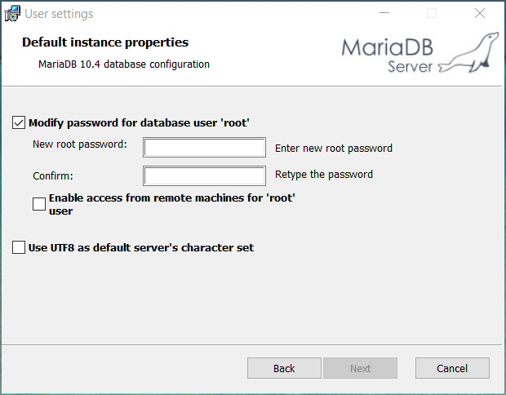

Pick a strong passphrase, enter it, and write it down. Click Next.

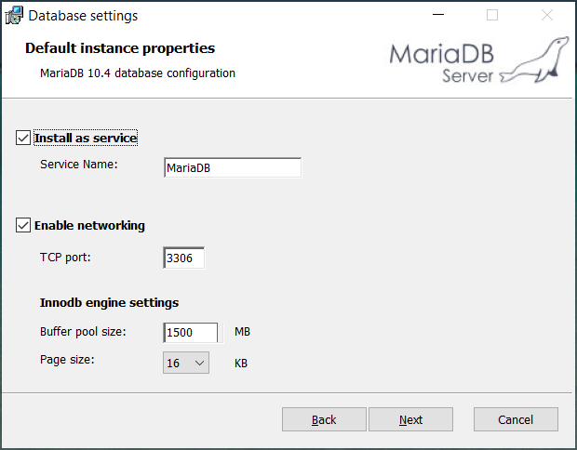

Click Next.

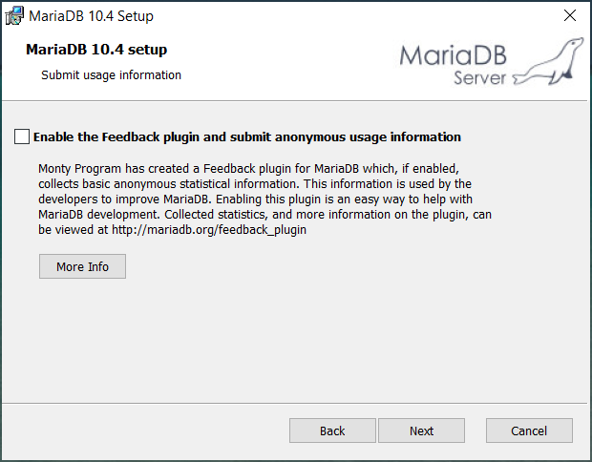

Click Next.

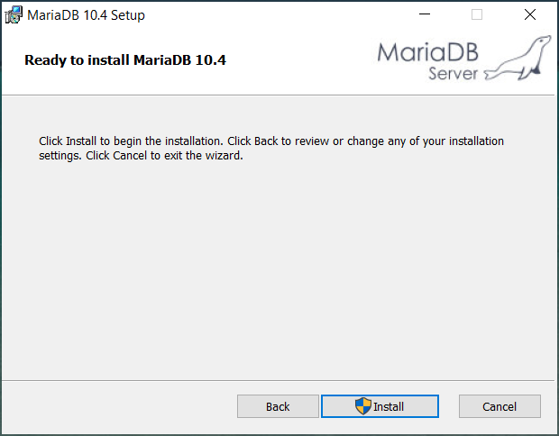

Click Install. Accept the User Account Control popup.

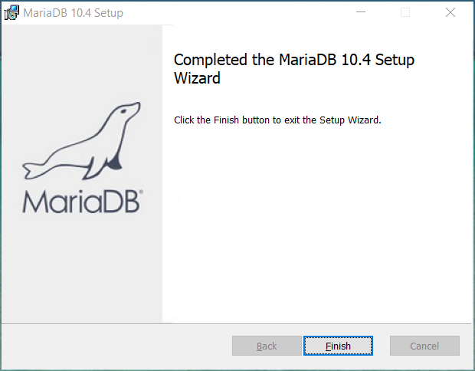

Click Finish.

MariaDB is now installed. Proceed to installing the viewer and administrator applications.

## Installing The Viewer And Administrator Applications

The viewer and administrator applications install via a text based installer. The file name is simply “Installer”. During the install, a User Account Control popup will appear. Click Yes. The viewer and / or administrator applications are now installed.

## Configuring MariaDB, Viewer, And Administrator Applications

The database application, MariaDB, must have the converted data loaded into it. Also, additional configuration is required of MariaDB, the viewer application, and the administrator application for the three to work together.

### Editing The Viewer And Administrator Application Config Files

Open file explorer and navigate to C:\MuseumApp. Right-click the **Museum Admin.exe.config** file, go to *Open With > Notepad*. See below for a screenshot.

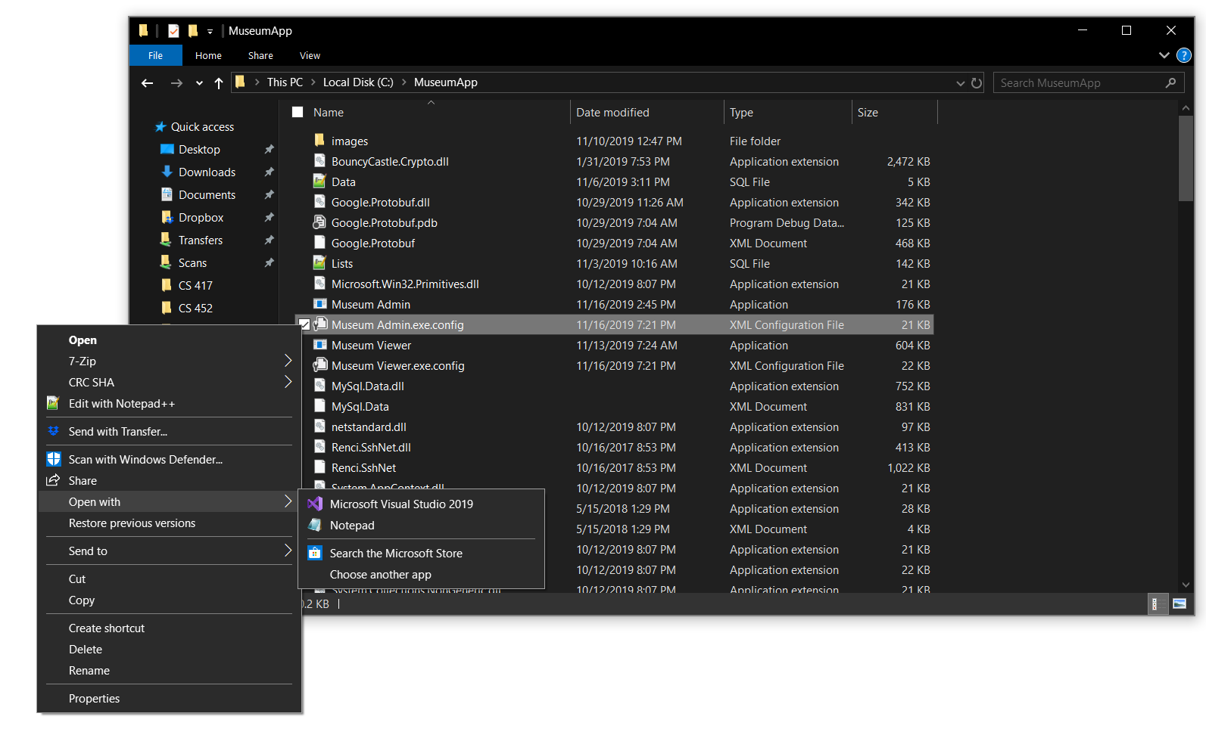

Once opened, look for the part **Password=InsertPasswordHere**. Change **InsertPasswordHere** to a strong passphrase, write it down. This passphrase should be different than the one created while installing MariaDB (at the end of installation, you should have 3 passwords: MariaDB, administrator application, and viewer application). Go to *File > Save* to save this file.This is the password the administrator application uses to access the database. It will not be needed for day to day operations. See below for a screenshot.

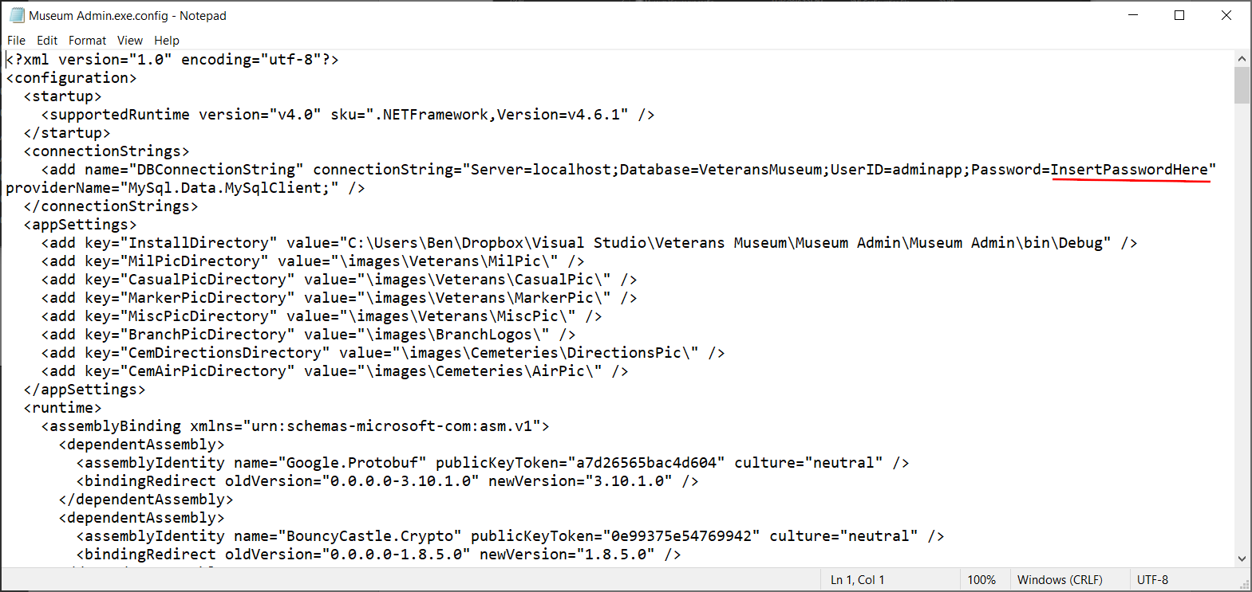

Repeat the *Open With > Notepad* and changing **InsertPasswordHere** for the **Museum Viewer.exe.config** file. Do not use the same password for the administrator and viewer config files.

### Editing The Database Users Config File

In the MuseumApp file explorer window, scroll down to find the file **Users.sql** (it may simply be shown as Users). Right click and *Open With > Notepad* as before. Once opened, change the **InsertPasswordHere** for adminapp and viewerapp to match the passwords set above in the config files. Go to *File > Save* to save this file.

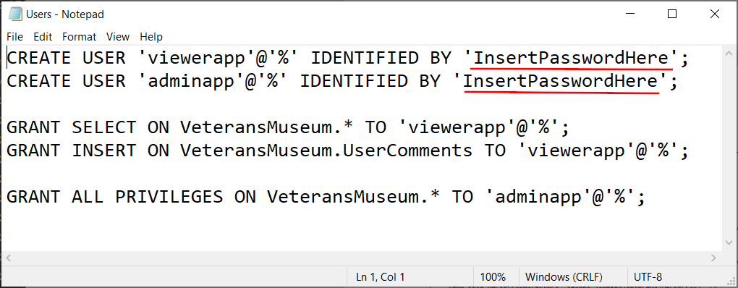

### Importing Data And Configuration Files Into The Database

Three files must be loaded into MariaDB: **Lists.sql**, **Users.sql**, and **Data.sql**. They must be loaded in the correct order. To begin loading the files, go to the start menu and look for the MariaDB folder (it will be named MariaDB [*version number*]). In this folder you should see a program named *MySQL Client (MariaDB [version number])*. Open this program to see a text based terminal window.

The first thing you will see is a prompt for the password. This is the password set up during the MariaDB install (see Installing MariaDB on page 12). Once you enter the password you will be greeted and will see a prompt *MariaDB [(none)]>*. To load a file into the database, use the *source* command. First, load the **Lists.sql** file using the command *source c:\museumapp\lists.sql*. You should see several lines flash on the screen saying *Query OK, 1 row affected (0.001 sec)*. Do not worry if the times differ, the Query OK part is what is important.

Once **Lists.sql** has loaded, the prompt should now change to *MariaDB [VeteransMuseum]>*. Time to load the next file, **Users.sql**. Type the command *source c:\museumapp\users.sql*. Again, you should see the *Query OK* messages. Finally, load the **Data.sql** file with the command *source c:\museumapp\data.sql*. Again, you should see the *Query OK* messages.

This completes the installation and configuration of the applications. Test the applications. In the event they do not work, reboot the computer and test again. Some configurations may not update without a computer restart.

### Importing Data And Configuration Files From Database Backup

Loading MariaDB with a backup file: **dailybackup_<date>-<time>.sql**. To begin loading the files, go to the start menu and look for the MariaDB folder (it will be named MariaDB [*version number*]). In this folder you should see a program named *MySQL Client (MariaDB [version number])*. Open this program to see a text based terminal window.

The first thing you will see is a prompt for the password. This is the password set up during the MariaDB install (see Installing MariaDB on page 12). Once you enter the password you will be greeted and will see a prompt *MariaDB [(none)]>*. To load a file into the database, use the *source* command. Load the most recent database file with *source c:\museumapp\backup\dailybackup_<date>-<time>.sql*

This completes the installation and configuration of the applications. Test the applications. In the event they do not work, reboot the computer and test again. Some configurations may not update without a computer restart.

## Setting up daily Backups

A file named BackupSQL.bat will be installed in the MuseumApp folder. Right-click this file and select edit. Two parameters must be set in order for the backup script for function properly. The “BackupFilePath” must be set to the folder where backups will be stored. This can be a local folder, a folder on an external hard disk, or even a google docs or dropbox folder in order to achieve offsite backups. The password for the adminapp, set while installing mariadb will be set as well.

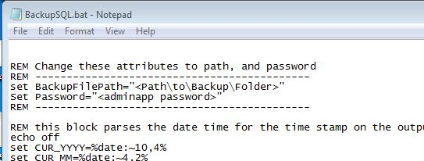

Once these parameters are set, click File in the top left corner, and save the file. From the Windows start menu type “Task Scheduler” into the search bar.

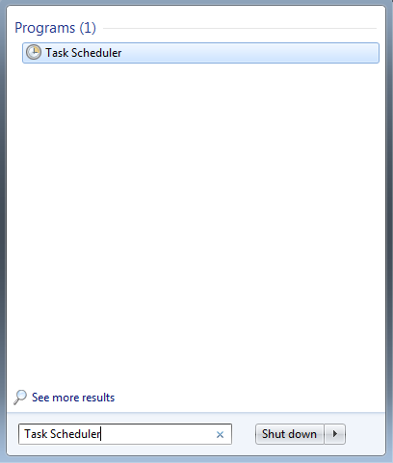

Once the task scheduler starts, select create a basic task, give the task an appropriate name.

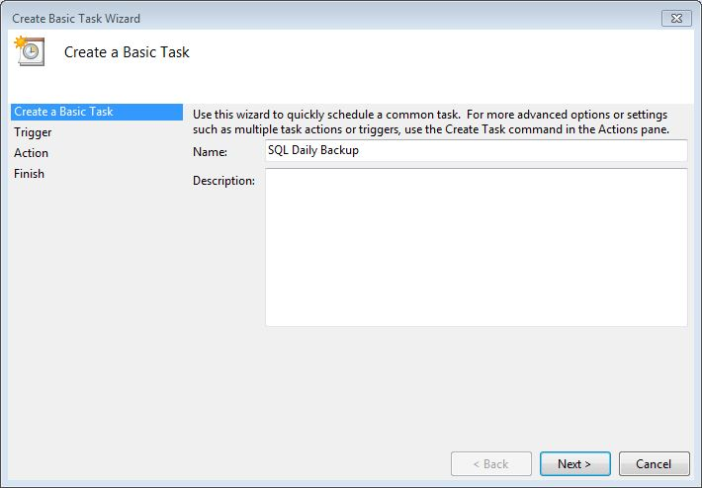

Click next

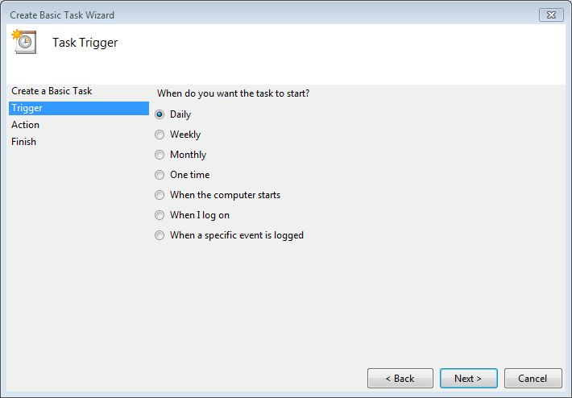

Select “Daily” for the trigger. Click next.

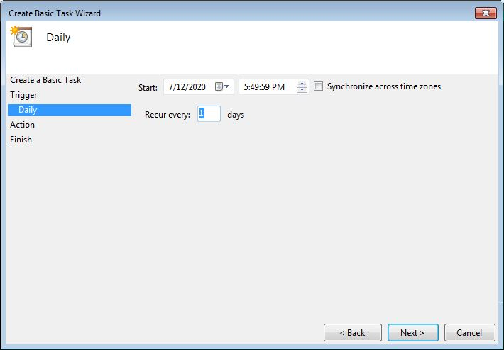

Select the start time and date and recurring time. Click next.

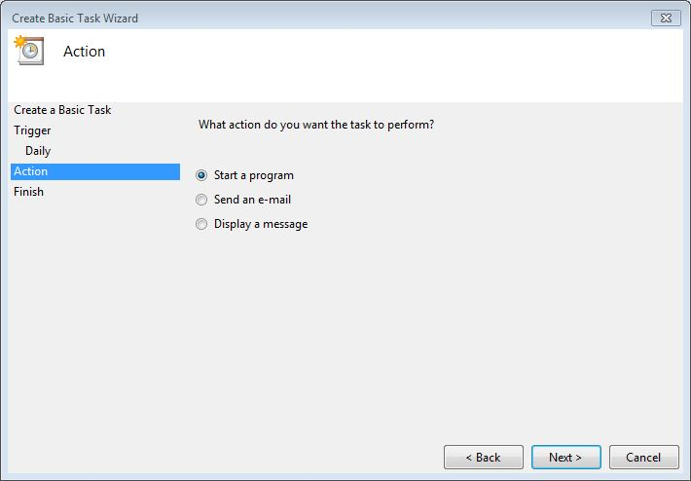

Chose “Start a Program” as the task to perform. Click next.

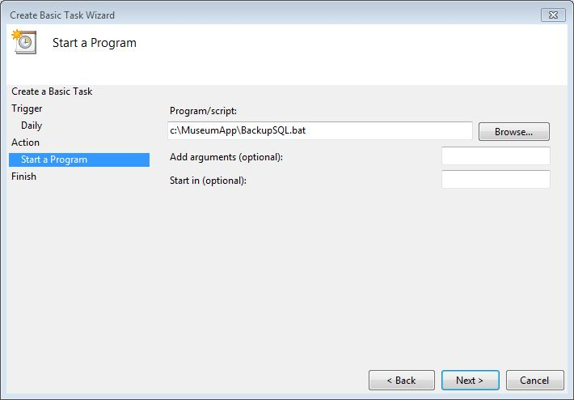

The path to the script should be *C:\MuseumApp\BackupSQL.bat*. Click next.

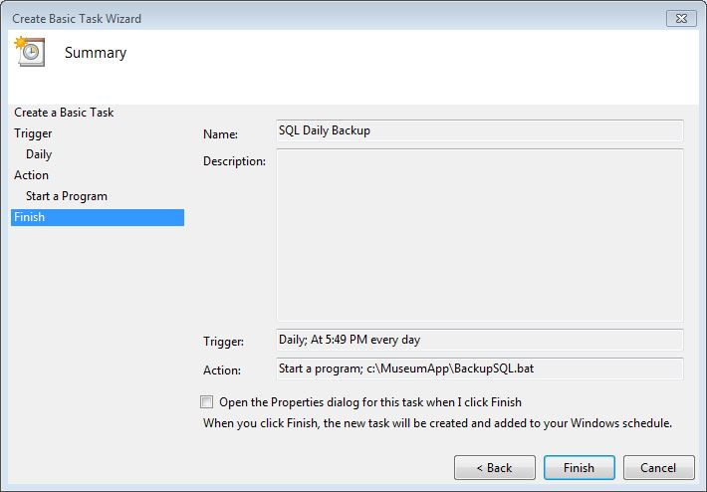

Click Finished. The backup solution should now be recurring daily.

# References

<https://mariadb.com/kb/en/library/installing-mariadb-msi-packages-on-windows/>

<https://mariadb.com/kb/en/library/create-user/>

<https://mariadb.com/kb/en/library/grant/>

<https://mariadb.com/kb/en/library/mysql-command-line-client/>